Sherman County Communications
204 W. 11th St., Goodland KS 67735
(785) 890-4575 ph
(785)890-4580 fax
shermancounty911@gmail.com

To the Applicant:

Thank you for your interest in the position of Communication Officer I. Please fill the application out accurately and completely. Please be sure and have your application notarized prior to submission.

You may return the information in person, by mail, e-mail or via fax. The building is locked after 4pm, but you can be buzzed in by the on-duty communication officer. Follow instructions on doorway.

After the receipt of your application, I will contact you to set up a time to complete the required testing. Please give me a phone number and email address that I can reach you at during regular business hours.

If you have any questions or require assistance with the application, please contact me at the number listed above.

Sincerely,

Crissy Livengood
Sherman County Communications Director
Emergency Management Assistant Coordinator

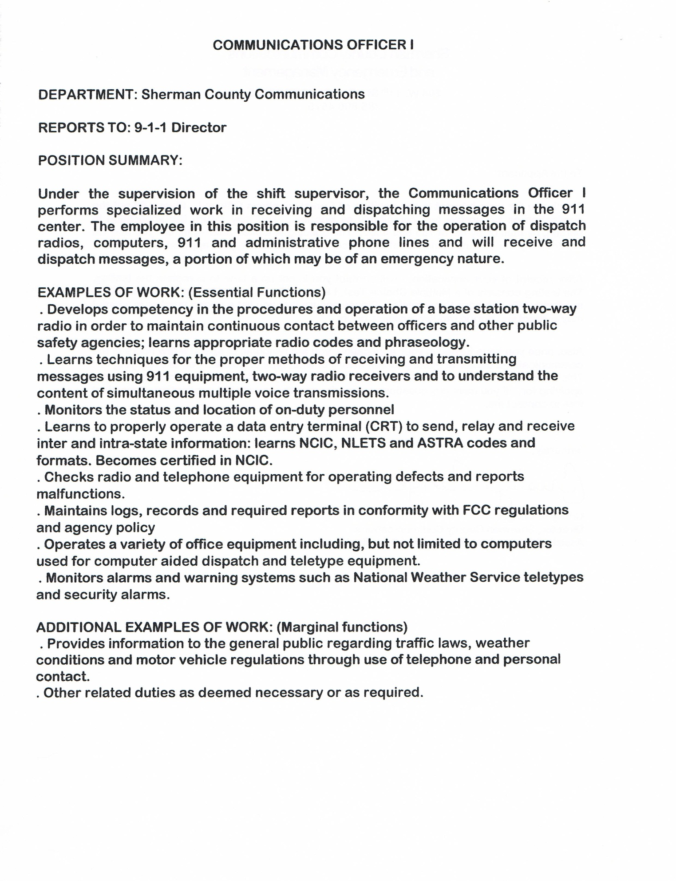
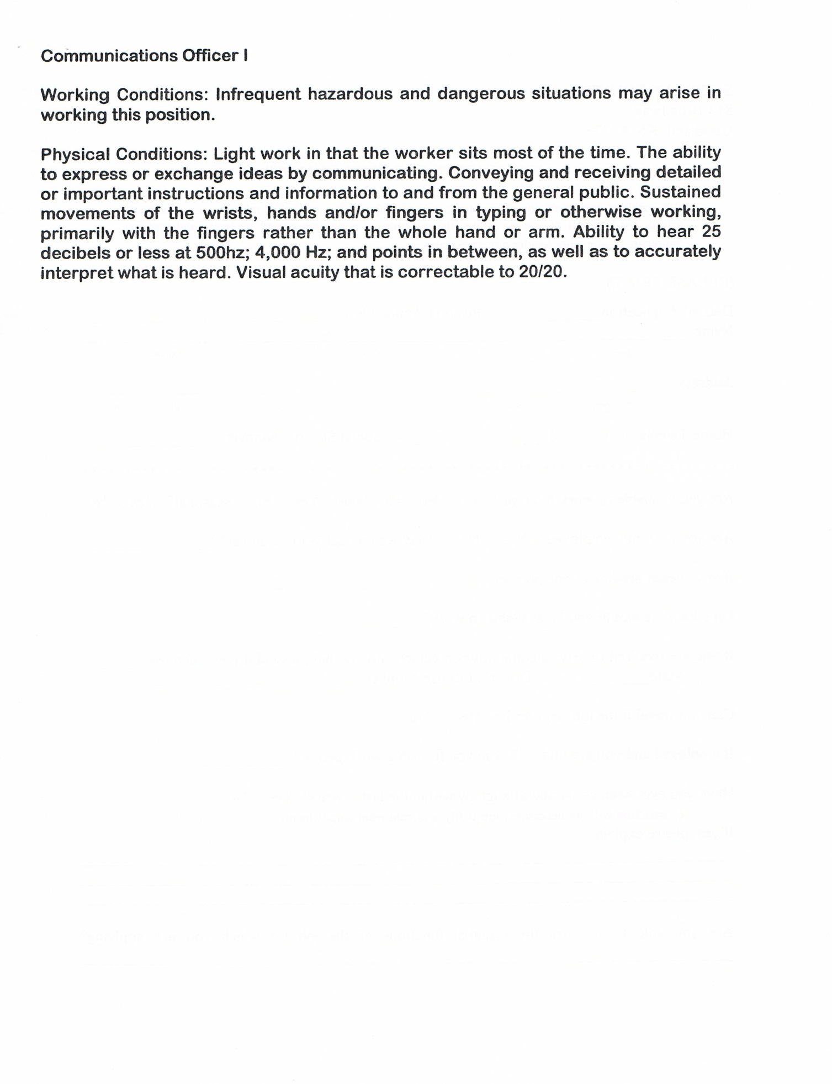
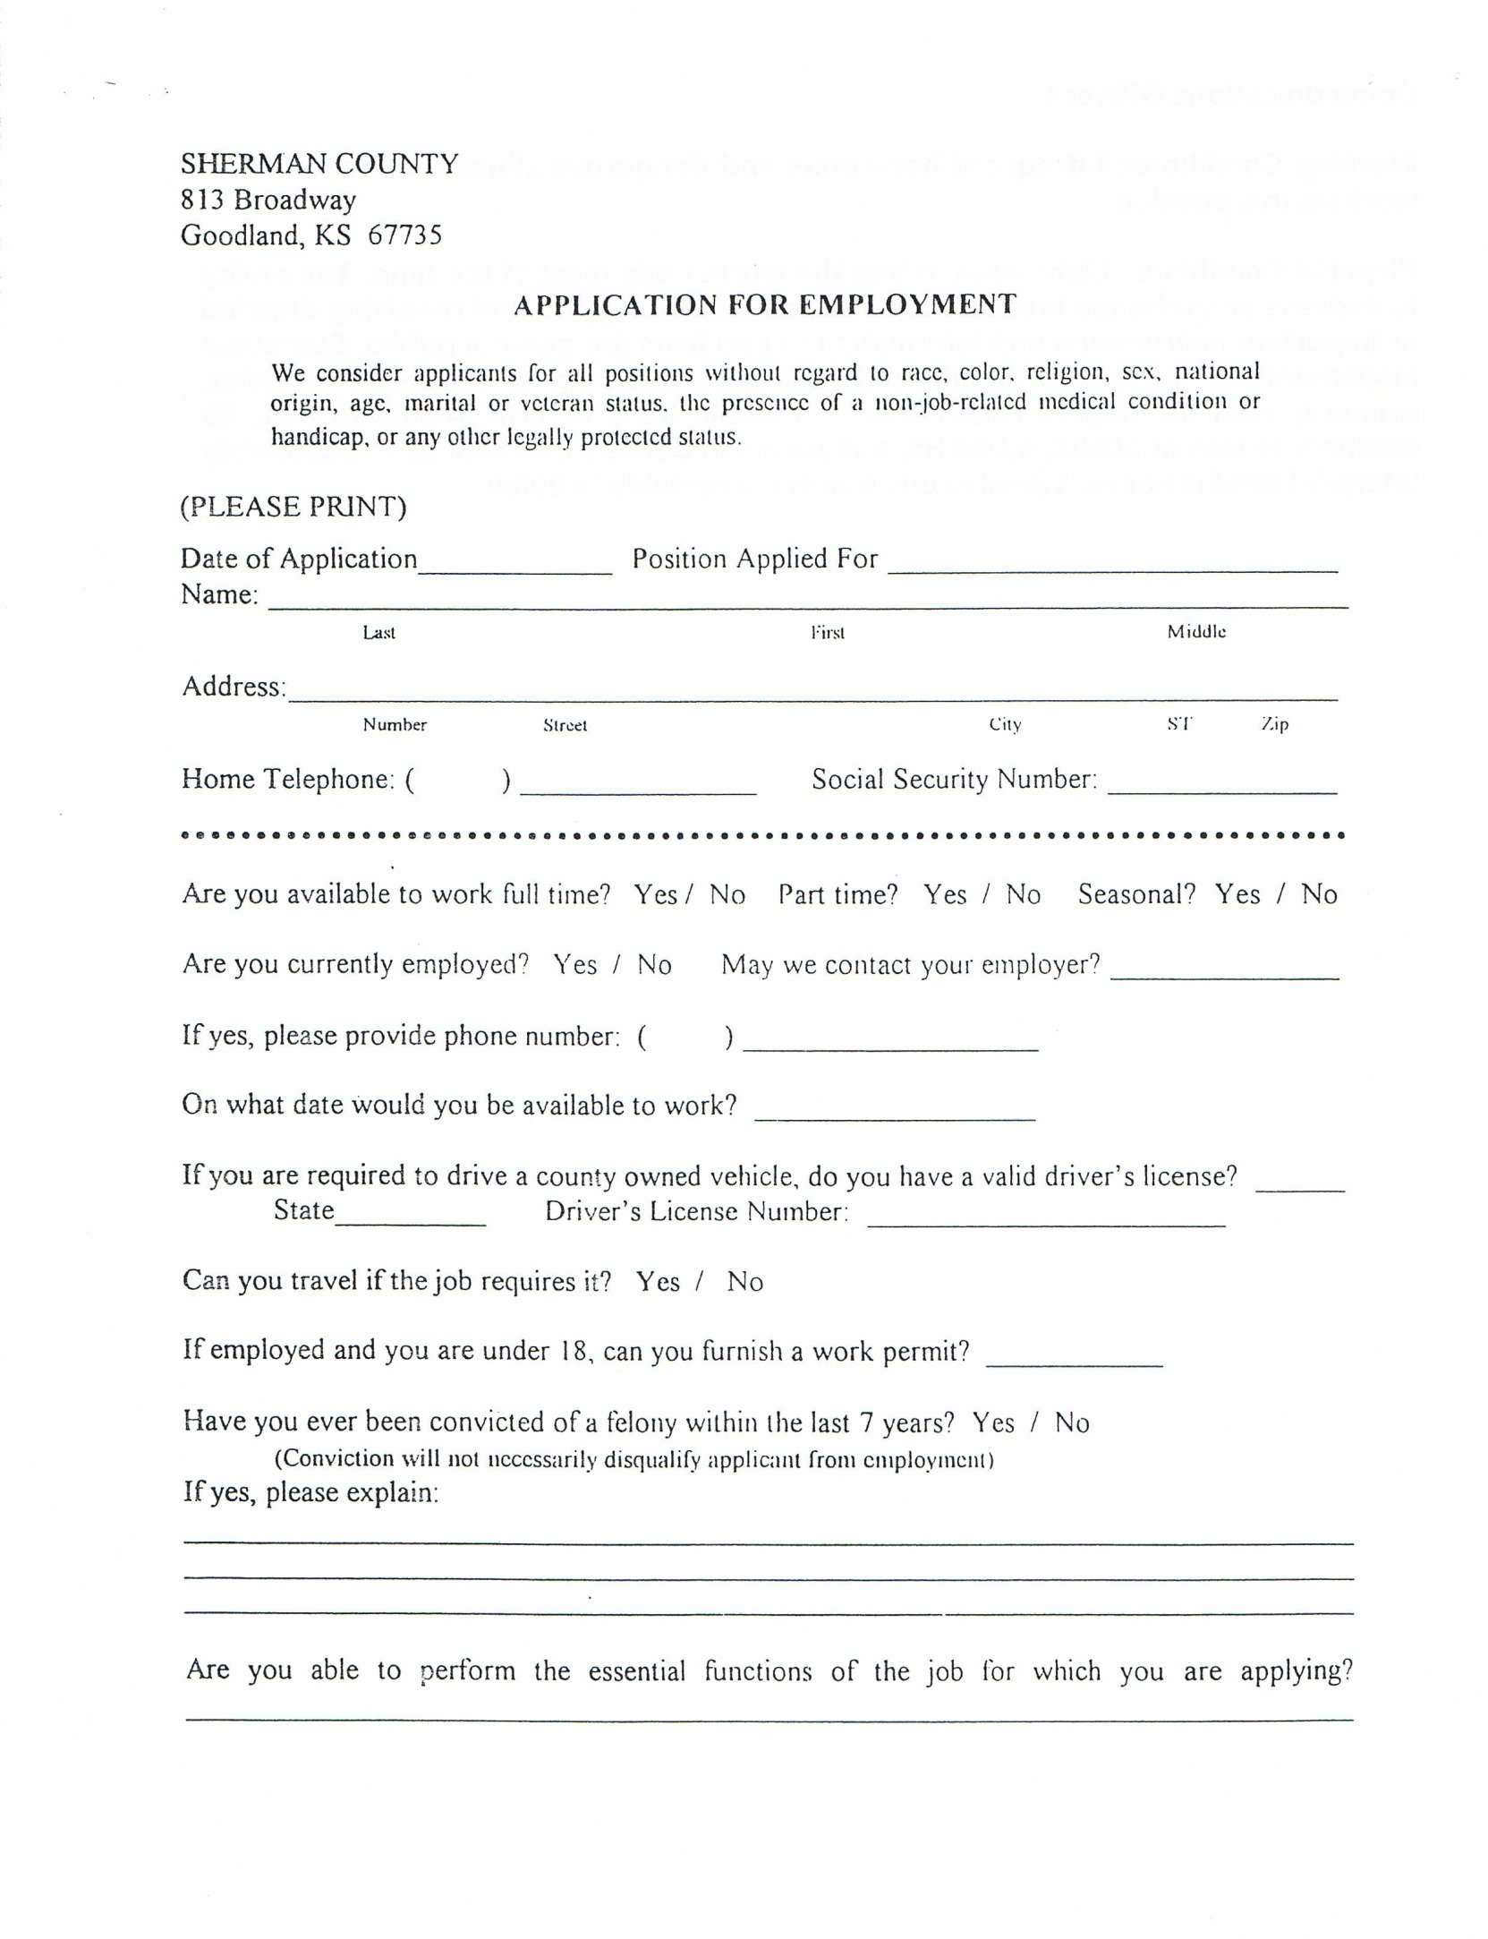
EMAIL ADDRESS: ______________________________________________________________
